RETENTION SCHEDULER
Project Description

Submitted to:

Prof. Ma. Rowena C. Solamo
Faculty Member
Department of Computer Science
College of Engineering
University of the Philippines, Diliman

Submitted by:
Joaquin, Neil Jonathan A.
Relao, David Paul A.
Simpao, Aldrin

In partial fulfillment of Academic Requirements
for the course
CS 191 Software Engineering I
of the
1st Semester, AY 2014-2015

Unique Reference:
The documents are stored in the https://github.com/bluenavy/ProjectDescription.

Document Purpose:
This document serves as a documentation of the development process of this project.

Target Audience:
students

Revision Control:
Revision Date | Person Responsible | Version  Number | Modification
8/26/94 | Yno, Neil, David | 1.0 | Initial Document;
8/27/14 | Yno | 1.1 | Added context diagram, document purpose and made quick fixes

Project Title: Retention Scheduler

Description: Every time that the student learns something from class, he can jot down notes directly to this app by noting them in a separate feature like notepad. The dates and time for this are noted as well. Along with this is a student calendar synced with a school year. This can provide the student a planner in which he can note his exam dates and other stuff like quizzes, seat-works, and recitations, with certain topics/lessons that the student needs to focus on for a specific pre-scheduled activity. The student will be reminded of the upcoming activity through pop-up alarms for around 3 times before the activity day on pre-defined hour of each day. More to that, the alarms contain randomized lesson parts or need-to-remember stuff that would be gotten from the notepad for student's retention as a preparation for the activity. Moreover, the students can pile up slides and educational stuff on an archive, for example, for better compilation of his stuff to study.

Context Diagram:
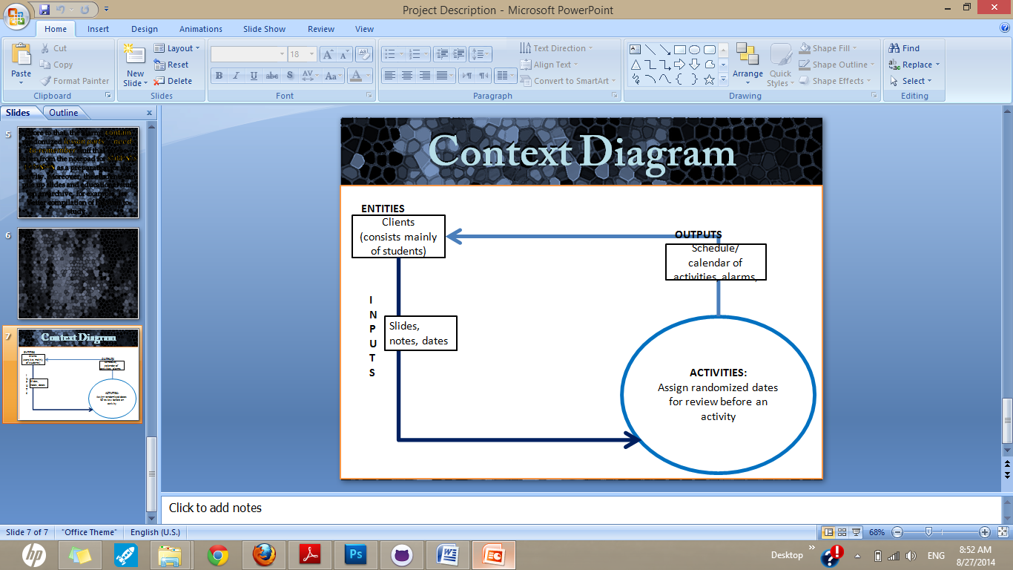

Place here the Context Diagram. Make sure that the diagram is grouped as one and text does not wrap around the diagram.

Entities:
user – the target audience giving inputs

Major Inputs:
[List of inputs]
slides, notes, dates of exam/quizzes

Major Outputs:
[List of outputs]
schedule, hidden dates for review

Major Functionalities:
[List of functionalities]
Scheduler
Pop-up quizzes on randomized dates

